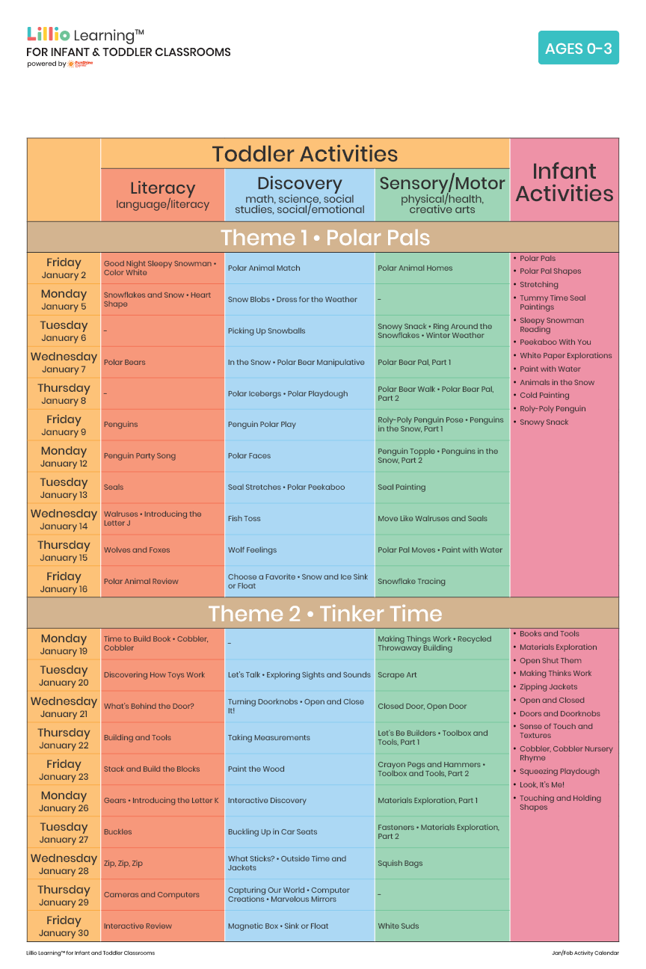
Add Your Name/Logo Here
January 2026
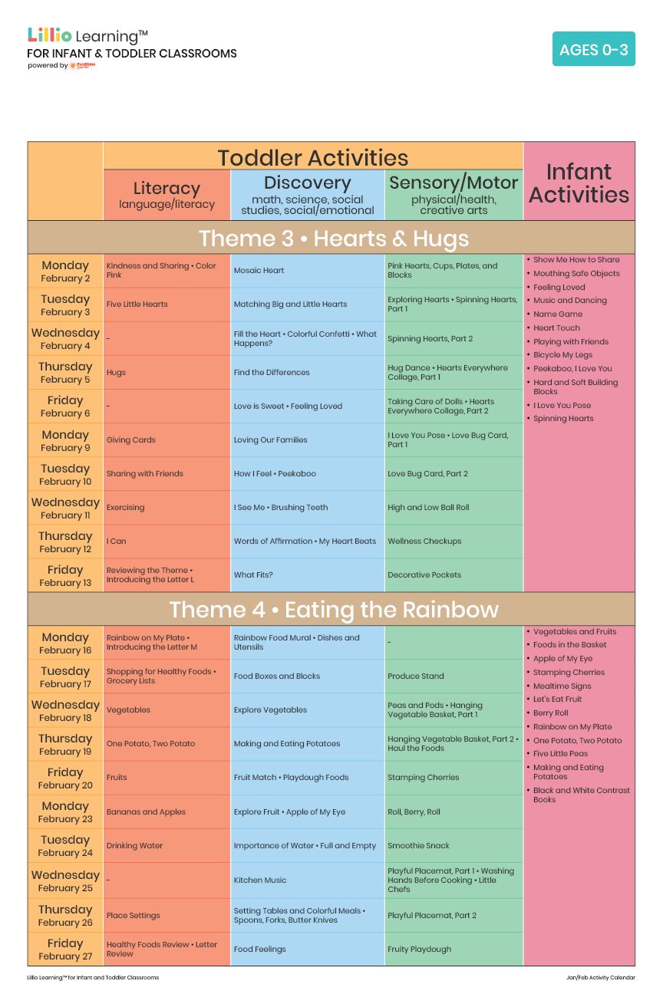
Add Your Name/Logo Here
February 2026

